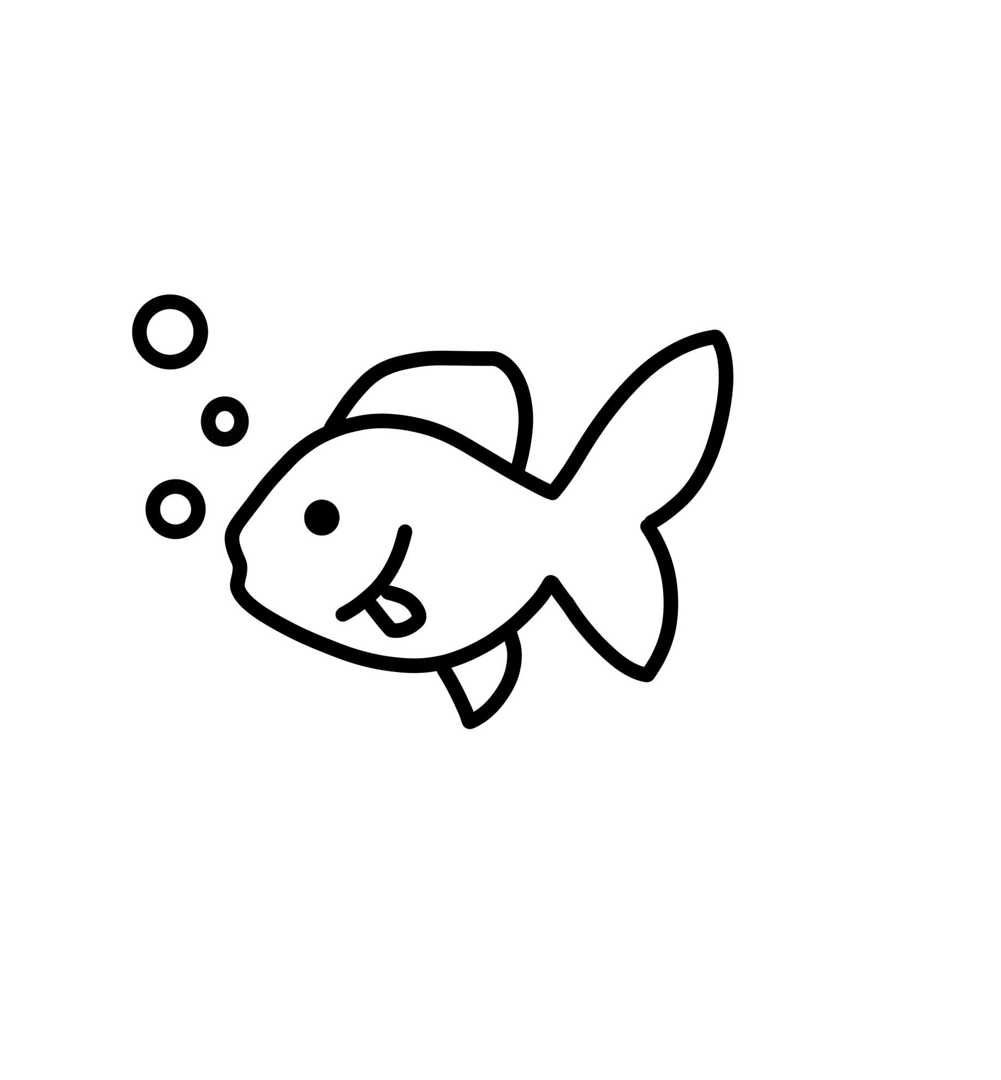

***AquaRoom***

Ethan Thomas, Jake Stewart, Gabriel Smith-Dalrymple, Gayathri Ramasamy, & Adrienne Co

August 21, 2019

# Executive Summary

AquaRoom is a mobile game targeting casual gamers interested in designing and maintaining aquariums. This game not only focuses on designing aquariums but also with heavy emphasis on aquascaping and gallery exhibits. With its mechanics and clean aesthetics, AquaRoom differs from existing fish care apps and definitely has a place among fish care games in the market.

# Overview

**Title**: AquaRoom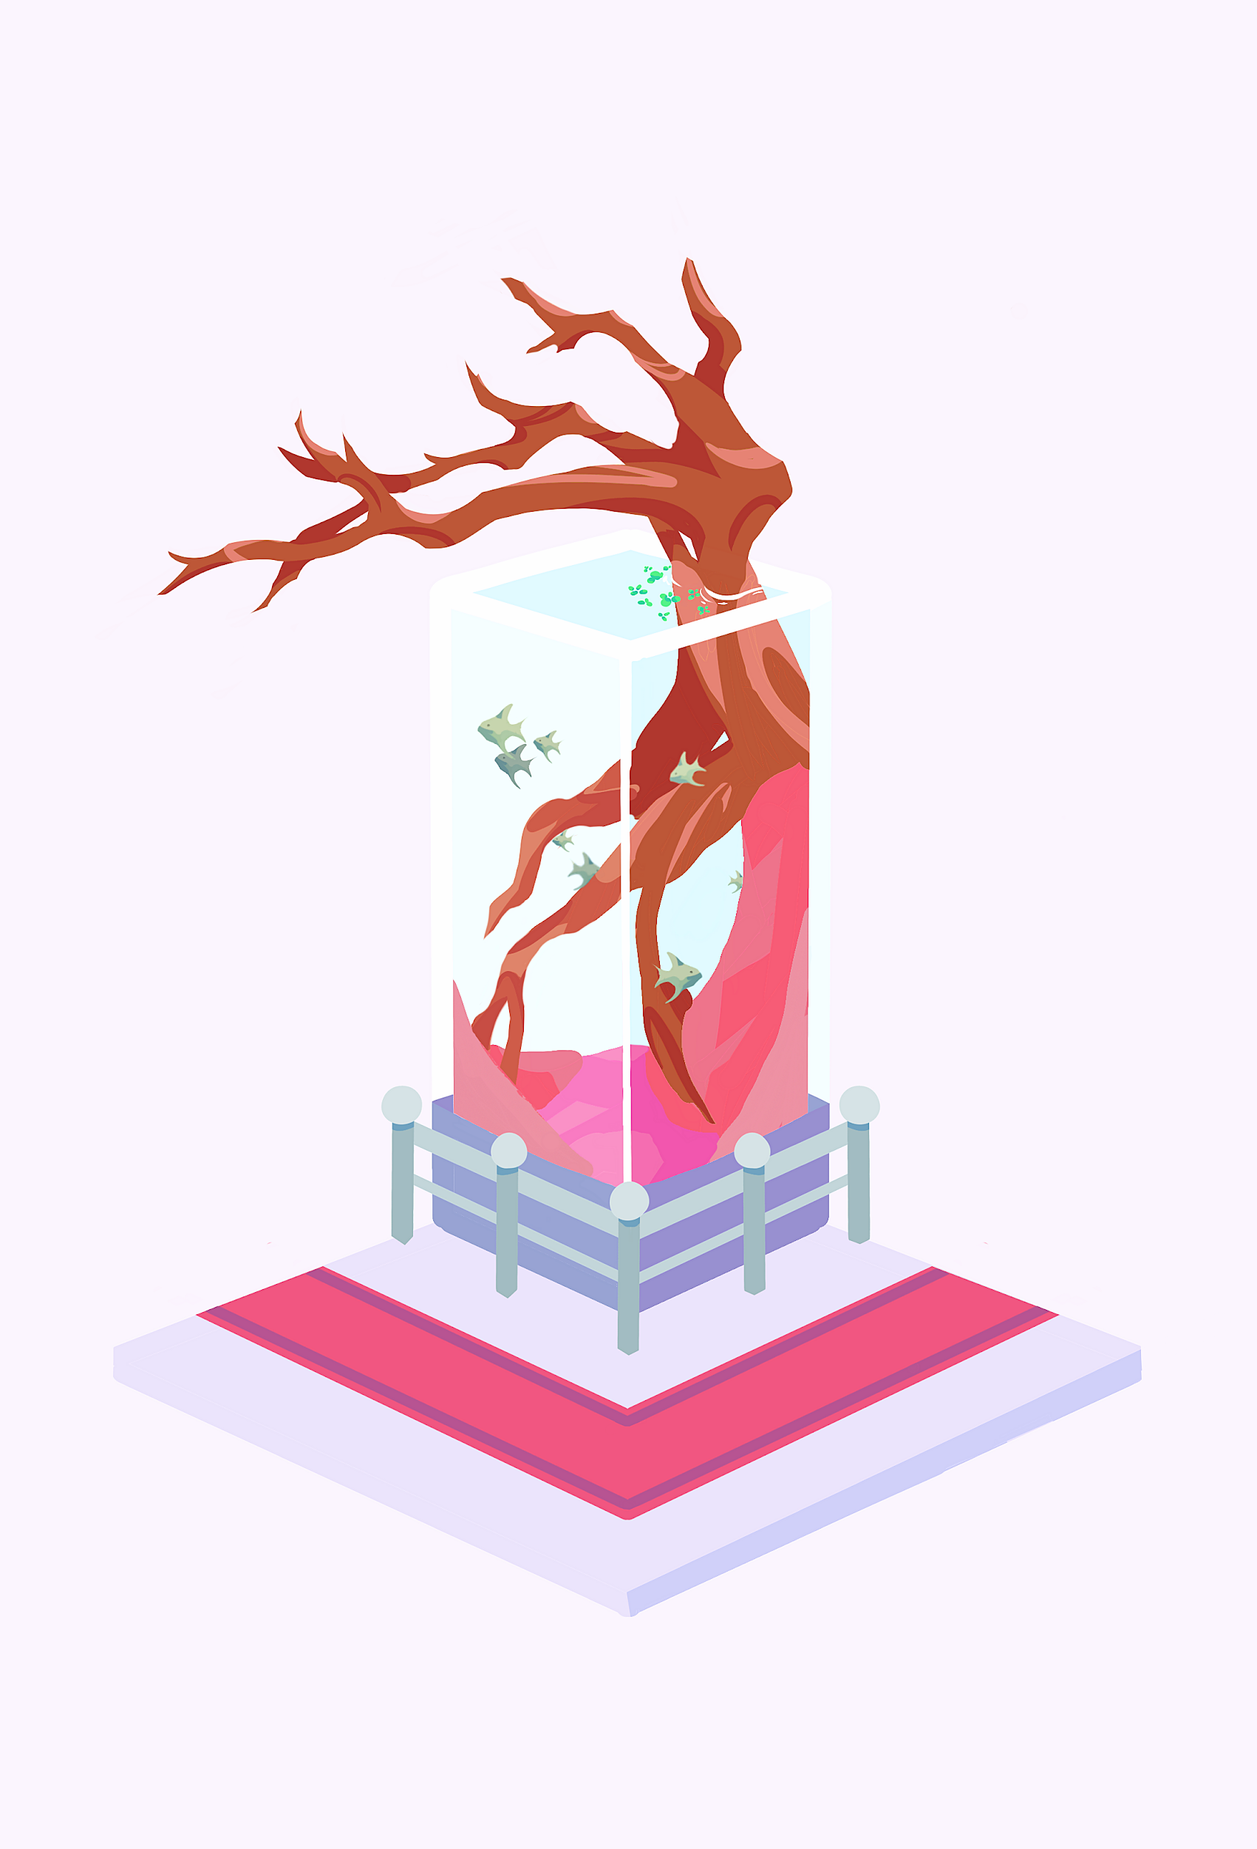

**Genre**: Design/Art, Idle, Virtual Pet

**Platform**: Android and iOS

**Target Audience**: Casual Gamers (People who play mobile games on avg. 24 min a day)

**Plays like** *Fish Live* meets *Home Grown*

**Goal**: Create aquarium aquascapes and exhibits to unlock more decorations and gallery space

**Major Mechanics**:

1. Design and decorate
2. Competing for “best tank” against other users’
3. Caring for fish

**Setting**: Aquarium Gallery

**References**: (games, books, movies…)

1. Viridi by Ice Water Games
2. Aquascaping: Aquarium Landscaping Like a Pro by Moe Martin

**Key Experiences**:

1. “Sense of accomplishment/pride for winning best tank”
2. “Feelings of joy and anticipation in sharing what you make and seeing what others make”
3. “Finding your (user’s) Zen”
4. “Feeling of self-discovery through player creativity”

**Selling Points**:

1. Puts a spin on existing fish care games by focusing on aquascaping and the outside environment
2. Game does not ask for or require lots of user data (e.g. access to contacts or internet history) and shows few mandatory ads
3. Game can be enjoyed slowly (without paying real money) or quickly (with real money), but the game never forces you to think that you must pay in order to move forward.

**Related Games**:

1. **Title**: *Fish Tycoon*

**Publisher/Developer**: Last Day of Work

**Genre**: Simulation

**Platform**: Android, iOS

**Year**: 2004

**How the game compares to ours:**

**Differs**: Business simulation, stress

**Similar**: Fish care, tank customization

**Market Performance**: Top-selling downloadable game from 2004 to 2006

**Critic’s Positive**/**Negative** **Points**:

* Overcomplicated gameplay mechanics/UI
* Poor graphics

1. **Title**: *Zen Koi 2*

**Publisher/Developer**: LandShark Games

**Genre**: Casual

**Platform**: Android, iOS

**Year**: 2018

**How the game compares to** **ours**:

**Differs**: Only koi fish, top down view

**Similar**: Fish care, customizable environment, stress-free

**Market Performance**: Over a million downloads and a 4.5 out of 5 on GooglePlay from 45,000 reviews

**Critic’s Positive/Negative Points**:

* Nice graphics and atmosphere
* Problems with loading
* Too many ads

# Related Games

Fish Tycoon

Fish Tycoon is a casual game created and developed by Last Day of Work. It was one of the top-selling downloadable games from 2004 to 2006. The main storyline was that players would take on the role of a fish store owner who must breed and care for hundreds of different kinds of exotic fish. The player would be doing all of this while attempting to keep the fish store economically viable long enough to achieve the ultimate objective: breeding The Seven Magic Fish of Isola.

Some similarities between Fish Tycoon and AquaRoom is:

* the setting is in a fish tank.
* the role of taking care of the fish.
* being able to purchase fish tank accessories using in-game currency.
* being able to customize the fish tank.
* being able to play the game on iOS and Android.

One of the most significant differences with Fish Tycoon compared to AquaRoom is that Fish Tycoon is more of a business simulator. AquaRoom is meant more like a very casual and stress-free game. Fish Tycoon centers around the player being able to breed and then sell the fish for whatever price they decide on. AquaRoom will not have this feature because this can cause some stress in players. Within Fish Tycoon, if the player does not take care of the fish or the tank, the fish can get sick, and the tank can get very dirty which will result in costing the player extra in-game currency to heal the fish and clean the tank.

One significant mistake that Fish Tycoon made that AquaRoom will avoid is making a causal game over complicated. For instance, an IGN game reviewer stated that "The game's biggest problem is that for such a casual idea, the gameplay mechanics are overly-complicated. Selling a fish requires catching it with the stylus, dragging it to the temporary tanks, clicking the menu, clicking Species, setting the price, exiting the menu, selecting the Sale Tank, releasing the fish, then accessing the Fish Store." (Adams, 2012) Another problem Fish Tycoon makes is either not marketing itself correctly or not refining the mechanics of the game. Critics on Metacritic pointed out "Terrible graphics and extremely limited interaction. Even my girlfriend, who normally gets obsessive about these sorts of pet games, lasted a day before she gave up." (Eurogamer, 2008). Also, Fish Tycoon appears to be more focused on breeding fish, while AquaRoom is more concentrated on aquascaping.

AquaRoom is marketed towards people who will only play this game for at most 24 minutes a day, ensuring that boredom can be mitigated. Since our game is supposed to be a stress-free, very casual game, it makes a point to not punish players for not taking care of the fish or tank. Our game will reward players for doing these actions, and we felt that players not wanting to show off dirty fish tanks was punishment enough. While Fish Tycoon does carry with it the same theme as AquaRoom, we do not feel AquaRoom will be in competition with Fish Tycoon because of these significant discrepancies.

Zen Koi 2

Zen Koi 2 is a free-to-play mobile game developed by LandShark Games. The game was inspired by the Asian myth about Koi ascending into dragons. The game follows a transcendent journey as the players guide their Koi in a tranquil and peaceful environment.

Some similarities between Zen Koi 2 and AquaRoom is:

* taking care of fish.
* being able to purchase decorations for the fish environment using in-game currency.
* being able to customize the fishes environment.
* the gameplay themes of emphasizing a stress free and very casual game.
* players can share their fish’s environment with friends.
* daily rewards.

Zen Koi 2 differs from AquaRoom in the fact that Zen Koi 2 is only concerned with Koi fish. Also, the view of their environment is a top-down view (how people in real life would view them). This top-down view limits what players can see and also really limits how the accessories of the fishes environment look to the player. In Zen Koi 2, the ultimate goal for the player is to collect enough “gems” to be able to expand their pond (Koi’s environment). Once the player has expanded the pond eight times, the Koi can then transform into “dragons.” AquaRoom does not have an ultimate goal. Also, plants that are in Zen Koi 2 have different actions that affect the Koi. For instance, red thorny plants will slow down the Koi’s movement, and white flower buds might blossom if a Koi swims by it, revealing a treasure that the player can collect. A small minor difference also is that in Zen Koi 2, the player can click a spot in the pond and a Koi will move there, presumably tied into the mechanics of the plants. Google Play reviewers enjoyed the personalization of the environment, graphics, and overall relaxing nature of the game.

There are more significant similarities with Zen Koi 2 then Fish Tycoon, but once again AquaRoom will still be able to set itself apart and differentiate itself within the fish game market. Some of the most significant differences are AquaRooms art, being able to have better views of the environment (e.g., players view the tank from many different angles). Zen Koi 2's goal is to transform the Koi while AquaRoom's goal is to create beautiful and fantastic fish tanks continually.

# Player Composites

1. When and where does this person play games?
   1. Players will play this game anytime they would typically play mobile games or when they are feeling bored and need a distraction. Marketing research* has shown that peak hours for mobile gaming is usually during commute times and lunchtime. Other peak times we expect is from 6 to 10 pm**.
   2. Players will play this game anywhere they usually play games on their phones. The game itself will be deployed on iOS and Android systems.
2. Who buys the games this person uses?
   1. This game will be available for download for free, so no purchase necessary. There will be in-game purchases (e.g., buying in-game currency) and those will be purchased using a credit card. So either the player will buy it or their family member (since this game is designed for all ages). Marketing research* has shown a “direct correlation between the amounts of money spent on virtual goods within social games and gamer age - the older the gamer, the more they spend.” So we will be marketing more heavily towards those users.
3. What platforms does this player use?
   1. This game is marketed towards very casual gamers. AquaRoom is targeting a wide range of players, from incidental players to transitionals. In the U.S., they make up 73% of the gaming market***.
4. How much time does this person spend in each session, and how frequent are gaming sessions?
   1. Based on market research* and playtesting, at most players will be playing the game for 24 minutes a day, but on average we expect anywhere from 5 minutes to 10 minutes. On average we expect players to at least play once a day*.
5. Who does the player play with?
   1. We are targeting people who either do not play games with anyone, or people who play games with family and friends.
6. What does the player like about games?
   1. We are targeting people who like to play mobile games for easy fun, distraction, and those that are looking for something to help relieve their stress. They do not like games that are not overly complicated or games that focus on competition. They do not like games that make them feel compelled to do specific actions. They enjoy games that allow them to express themselves freely through their work (artwork).
7. What (non-game) brand images appeal to this player?
   1. Google research**** has shown that Youtube gamers (people who play games and also watch other people play games on youtube at least once a month) are more likely to purchase items than regular online population. Brands that usually interest them are entertainment, electronic, computer, smartphone, and car brands.
8. How much disposable income does this player have?
   1. Based on research*****, on average the player, for entertainment, will have a disposable income range of $1750 to $3499 per year.
9. What competes with gaming time for this player?
   1. Other sources of entertainment such as movie theaters, tv shows, online streaming (e.g., Youtube, Twitch, etc).

Sources:

*: <https://www.mmaglobal.com/research/myth-busting-mobile-gaming-demographics>

**:<https://influencermarketinghub.com/mobile-gaming-statistics/>

***:[https://www.polygon.com/2018/8/27/17671972/gamer-types-habits-demographic-researc h-eeda](https://www.polygon.com/2018/8/27/17671972/gamer-types-habits-demographic-research-eeda)

****:<https://www.thinkwithgoogle.com/consumer-insights/why-gamers-should-be-part-your-audience-strategy/>

*****:<https://www.chartboost.com/wp-content/uploads/2017/05/ChartboostMobileGamingAudience.pdf>

# Art Direction

All art assets are simple 3D-models with cel-shading and a pastel colour palette. Inherently more complex assets (such as the branches) will have lower polygons in the final game in consideration of loading times. Overall, the core aesthetics should be simple enough to not overwhelm the mobile system or clutter the screen. The range of colour values can be similar to that of *Viridi* by Ice Water Games. The softer palette is meant to support the relaxing feel of the game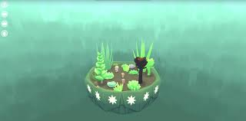

*Viridi* Screen Shot (Colour value reference)

*AquaRoom* Example Exhibit 1

**Lighting**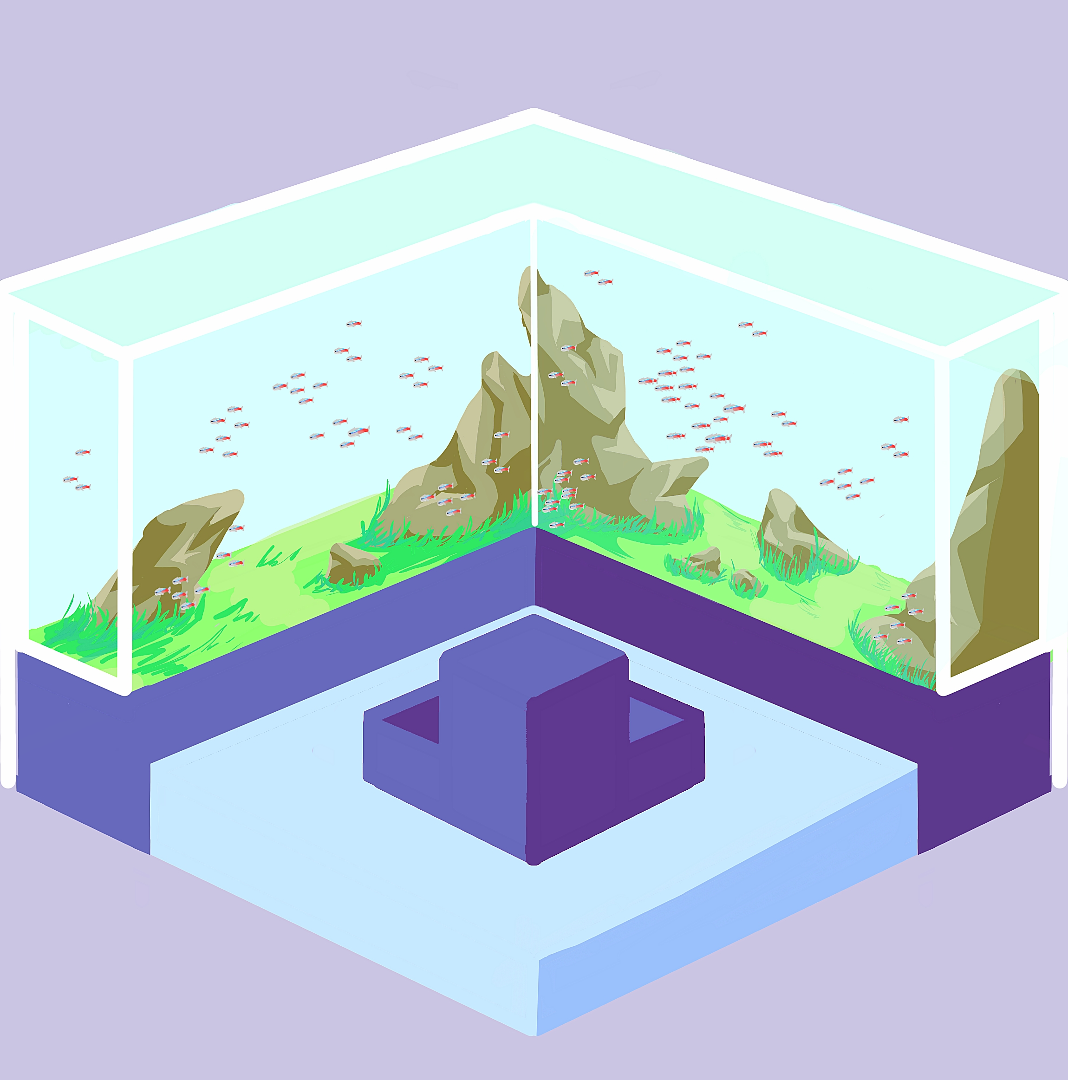

There will be no real-time lighting rendering because of technological constraints (but testing still needs to be done to prove otherwise). At this stage, assets will be pre-lit to the same lightsource as there is no dynamic lighting.

**Animations**

The fish will be animated according to simple patterns depending on their tank location. Keeping constraints regarding loading and dropped frames in mind when running multiple animations, there will only be subtle animations for applicable decorations (e.g. swaying plants or oscillating lights). *AquaRoom* Example Exhibit 2

**Additional Current Assets**

**Decorational Plants**



# 

# 

# Bamboo Branches

**Fish**

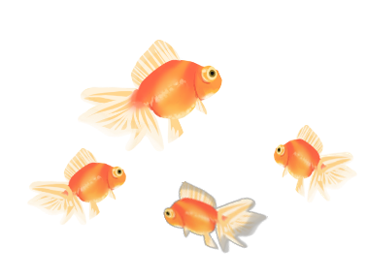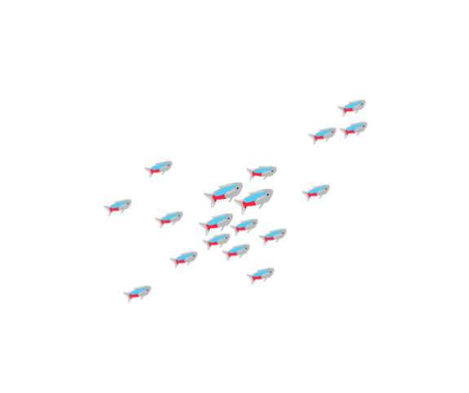

# 

# 

Goldfish Neon Tetras

# User Interface Storyboards

**Begin an exhibit by choosing a base**

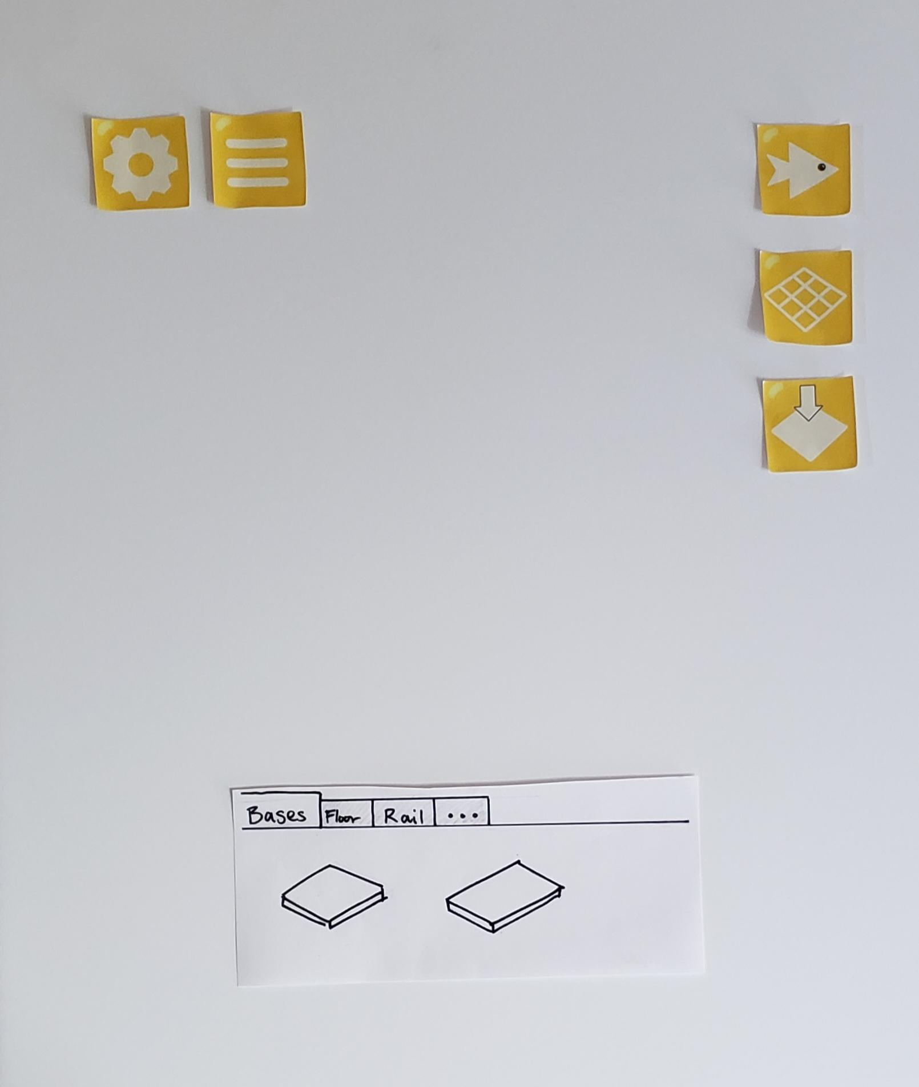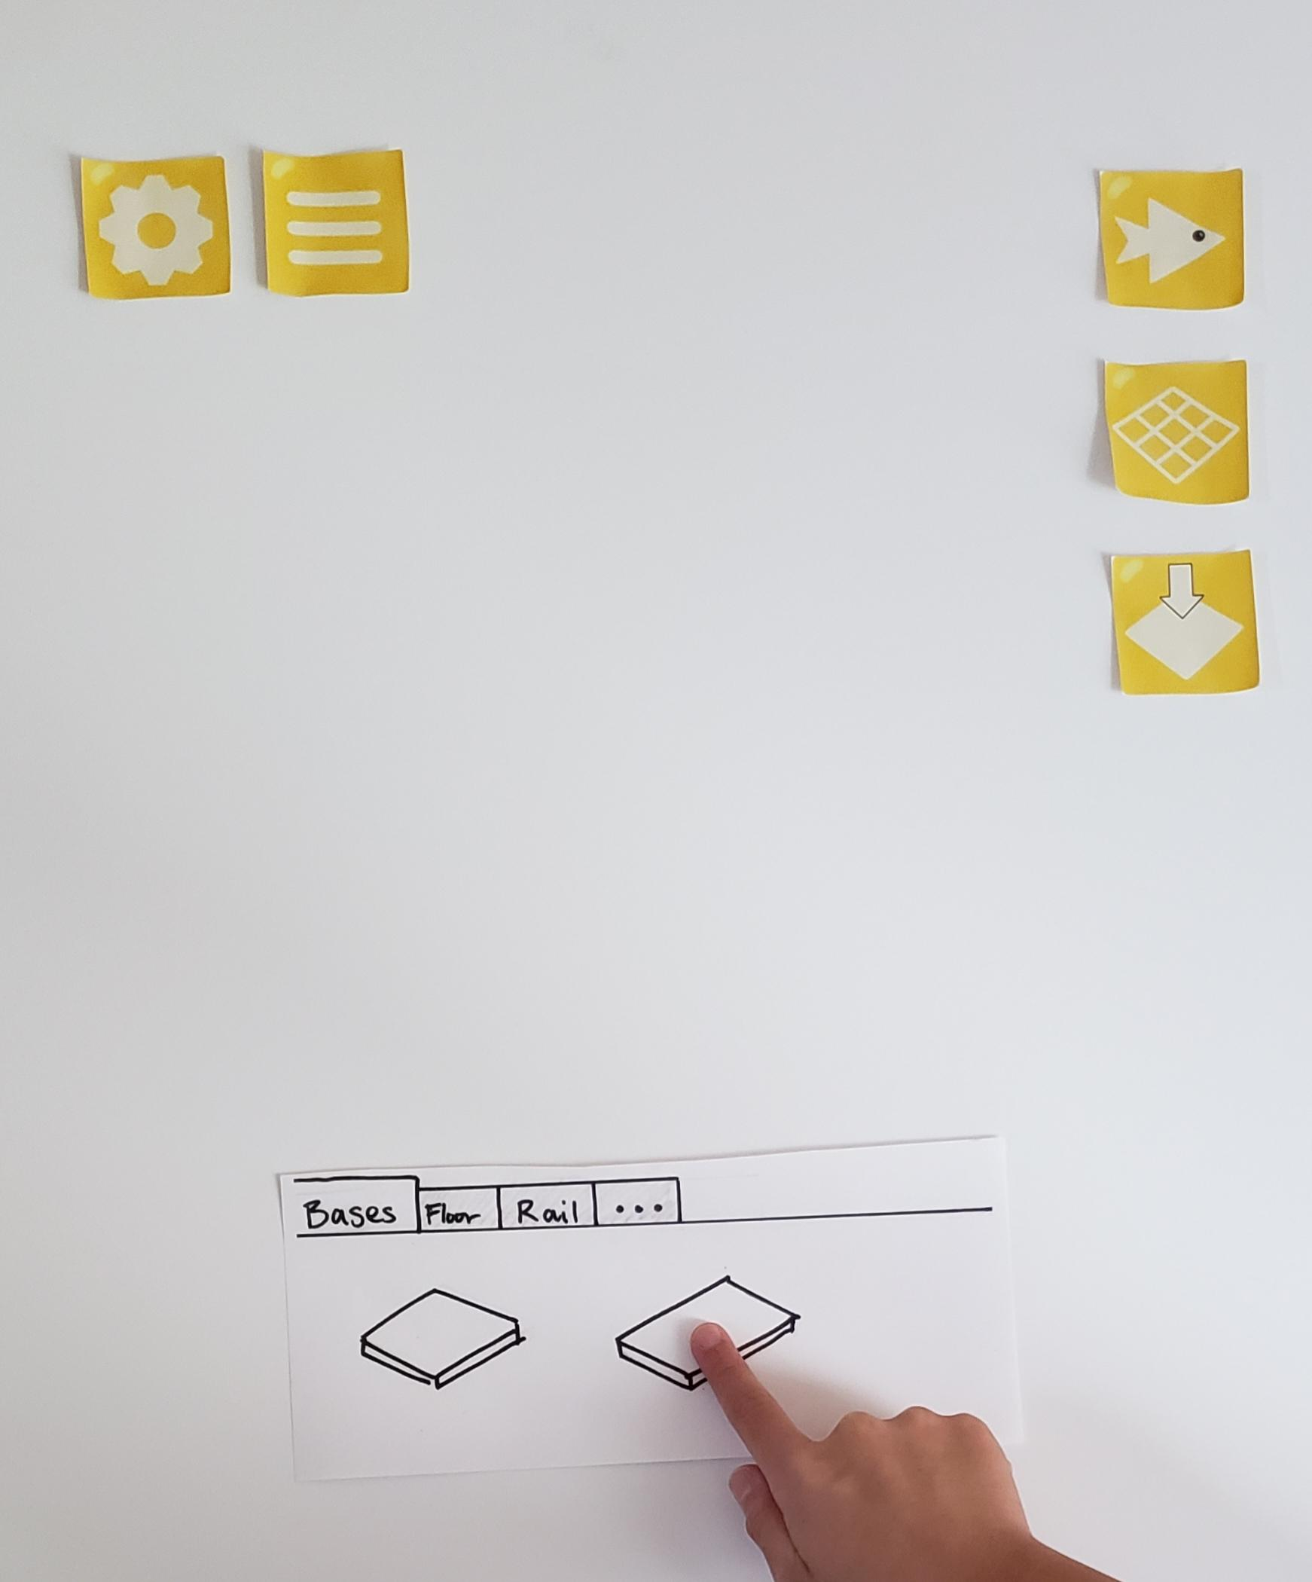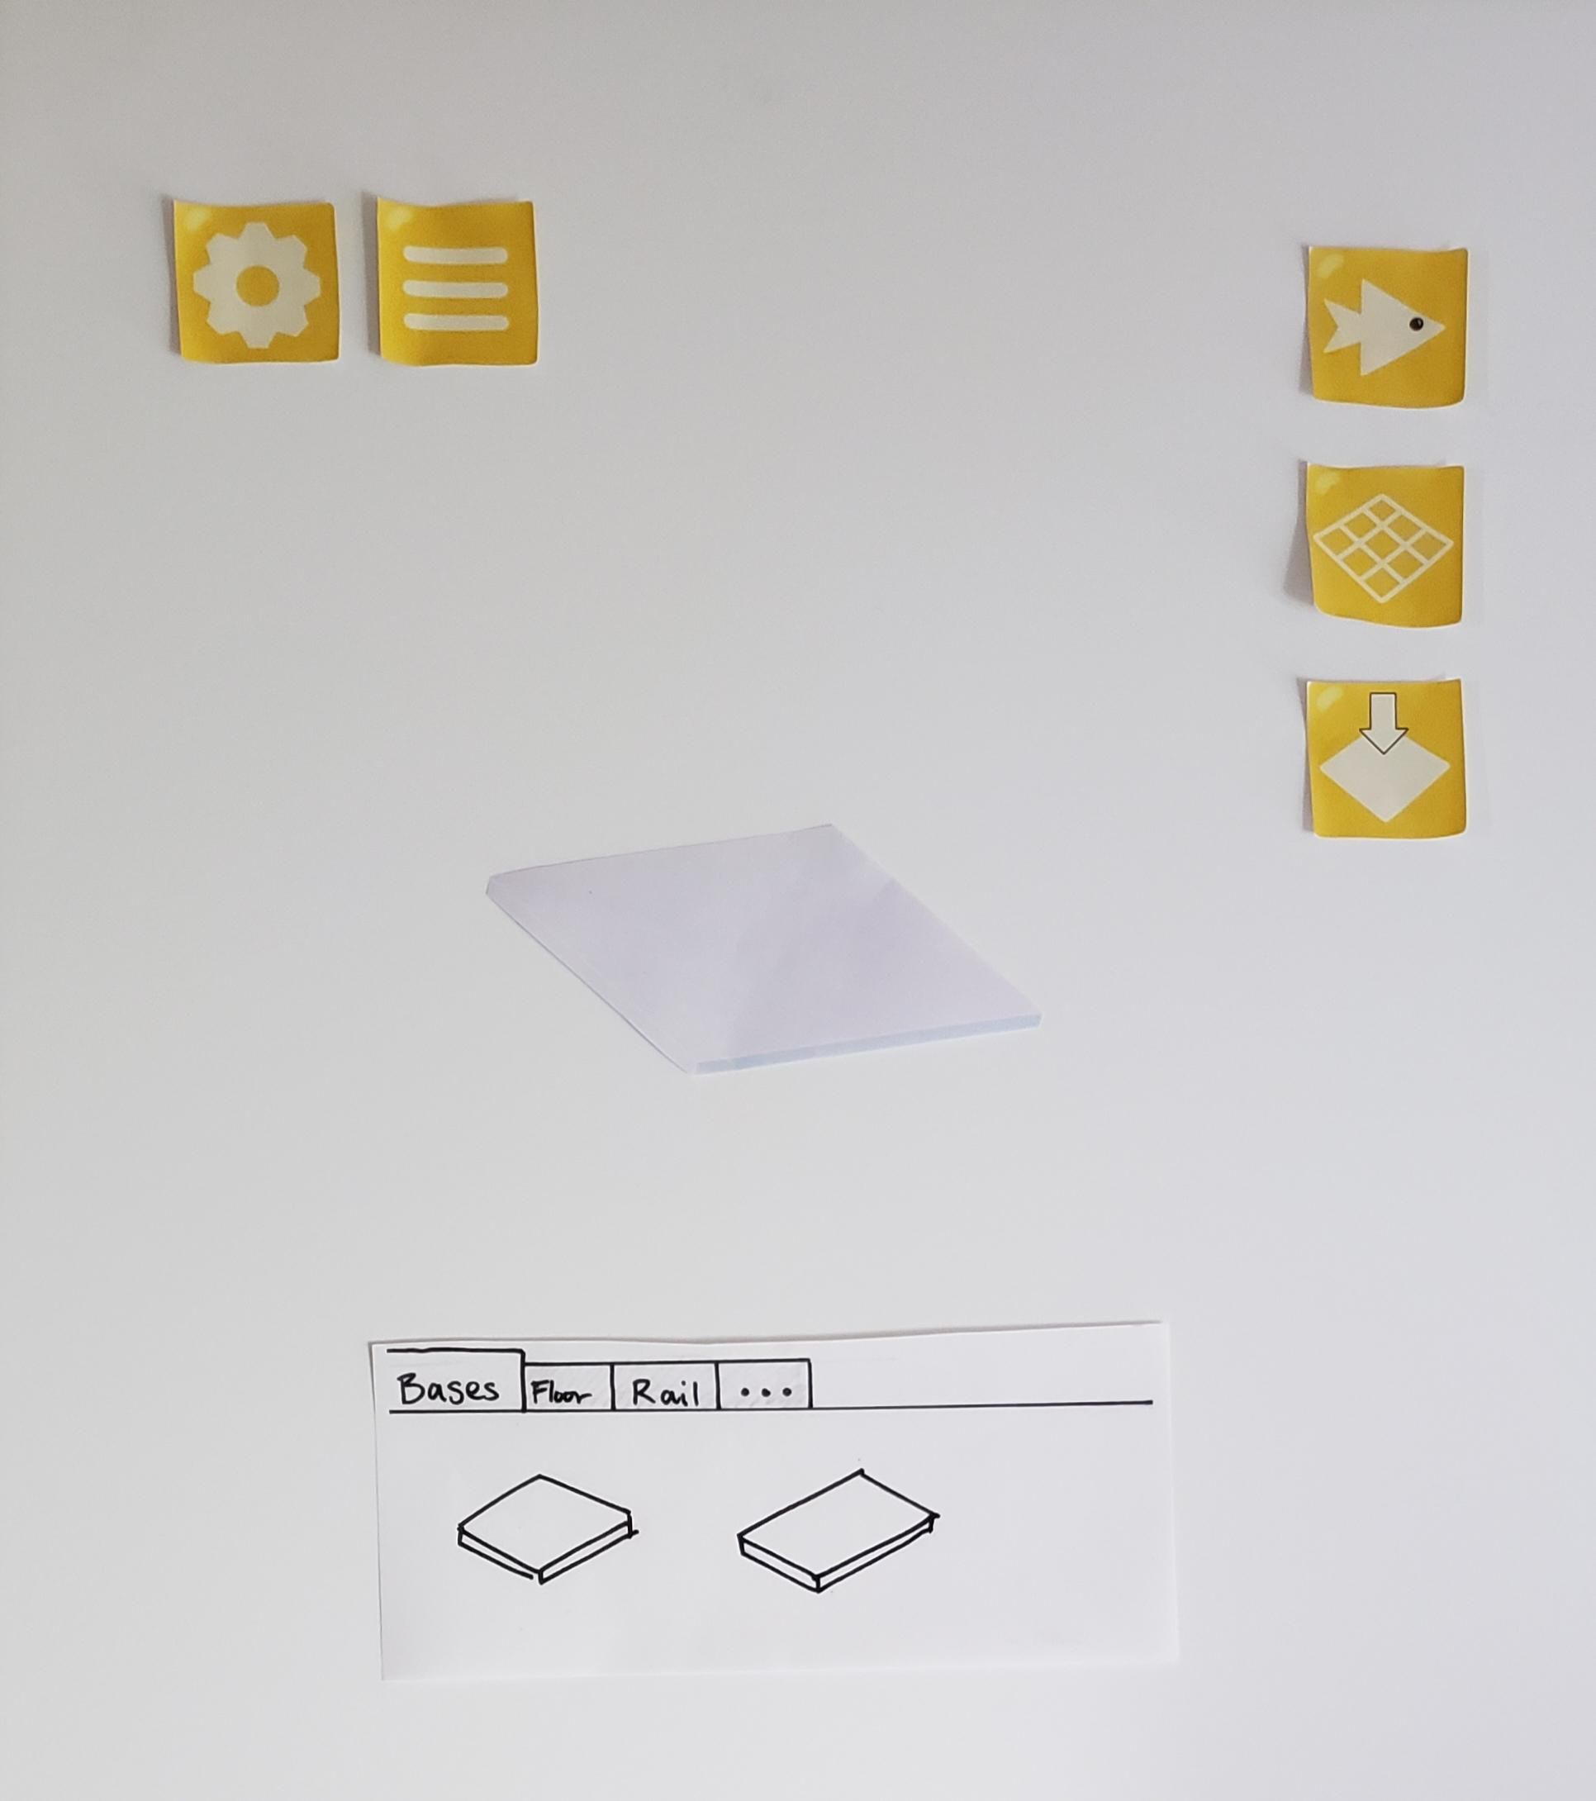

**Decorate a Tank (Start tank and add a ground)**

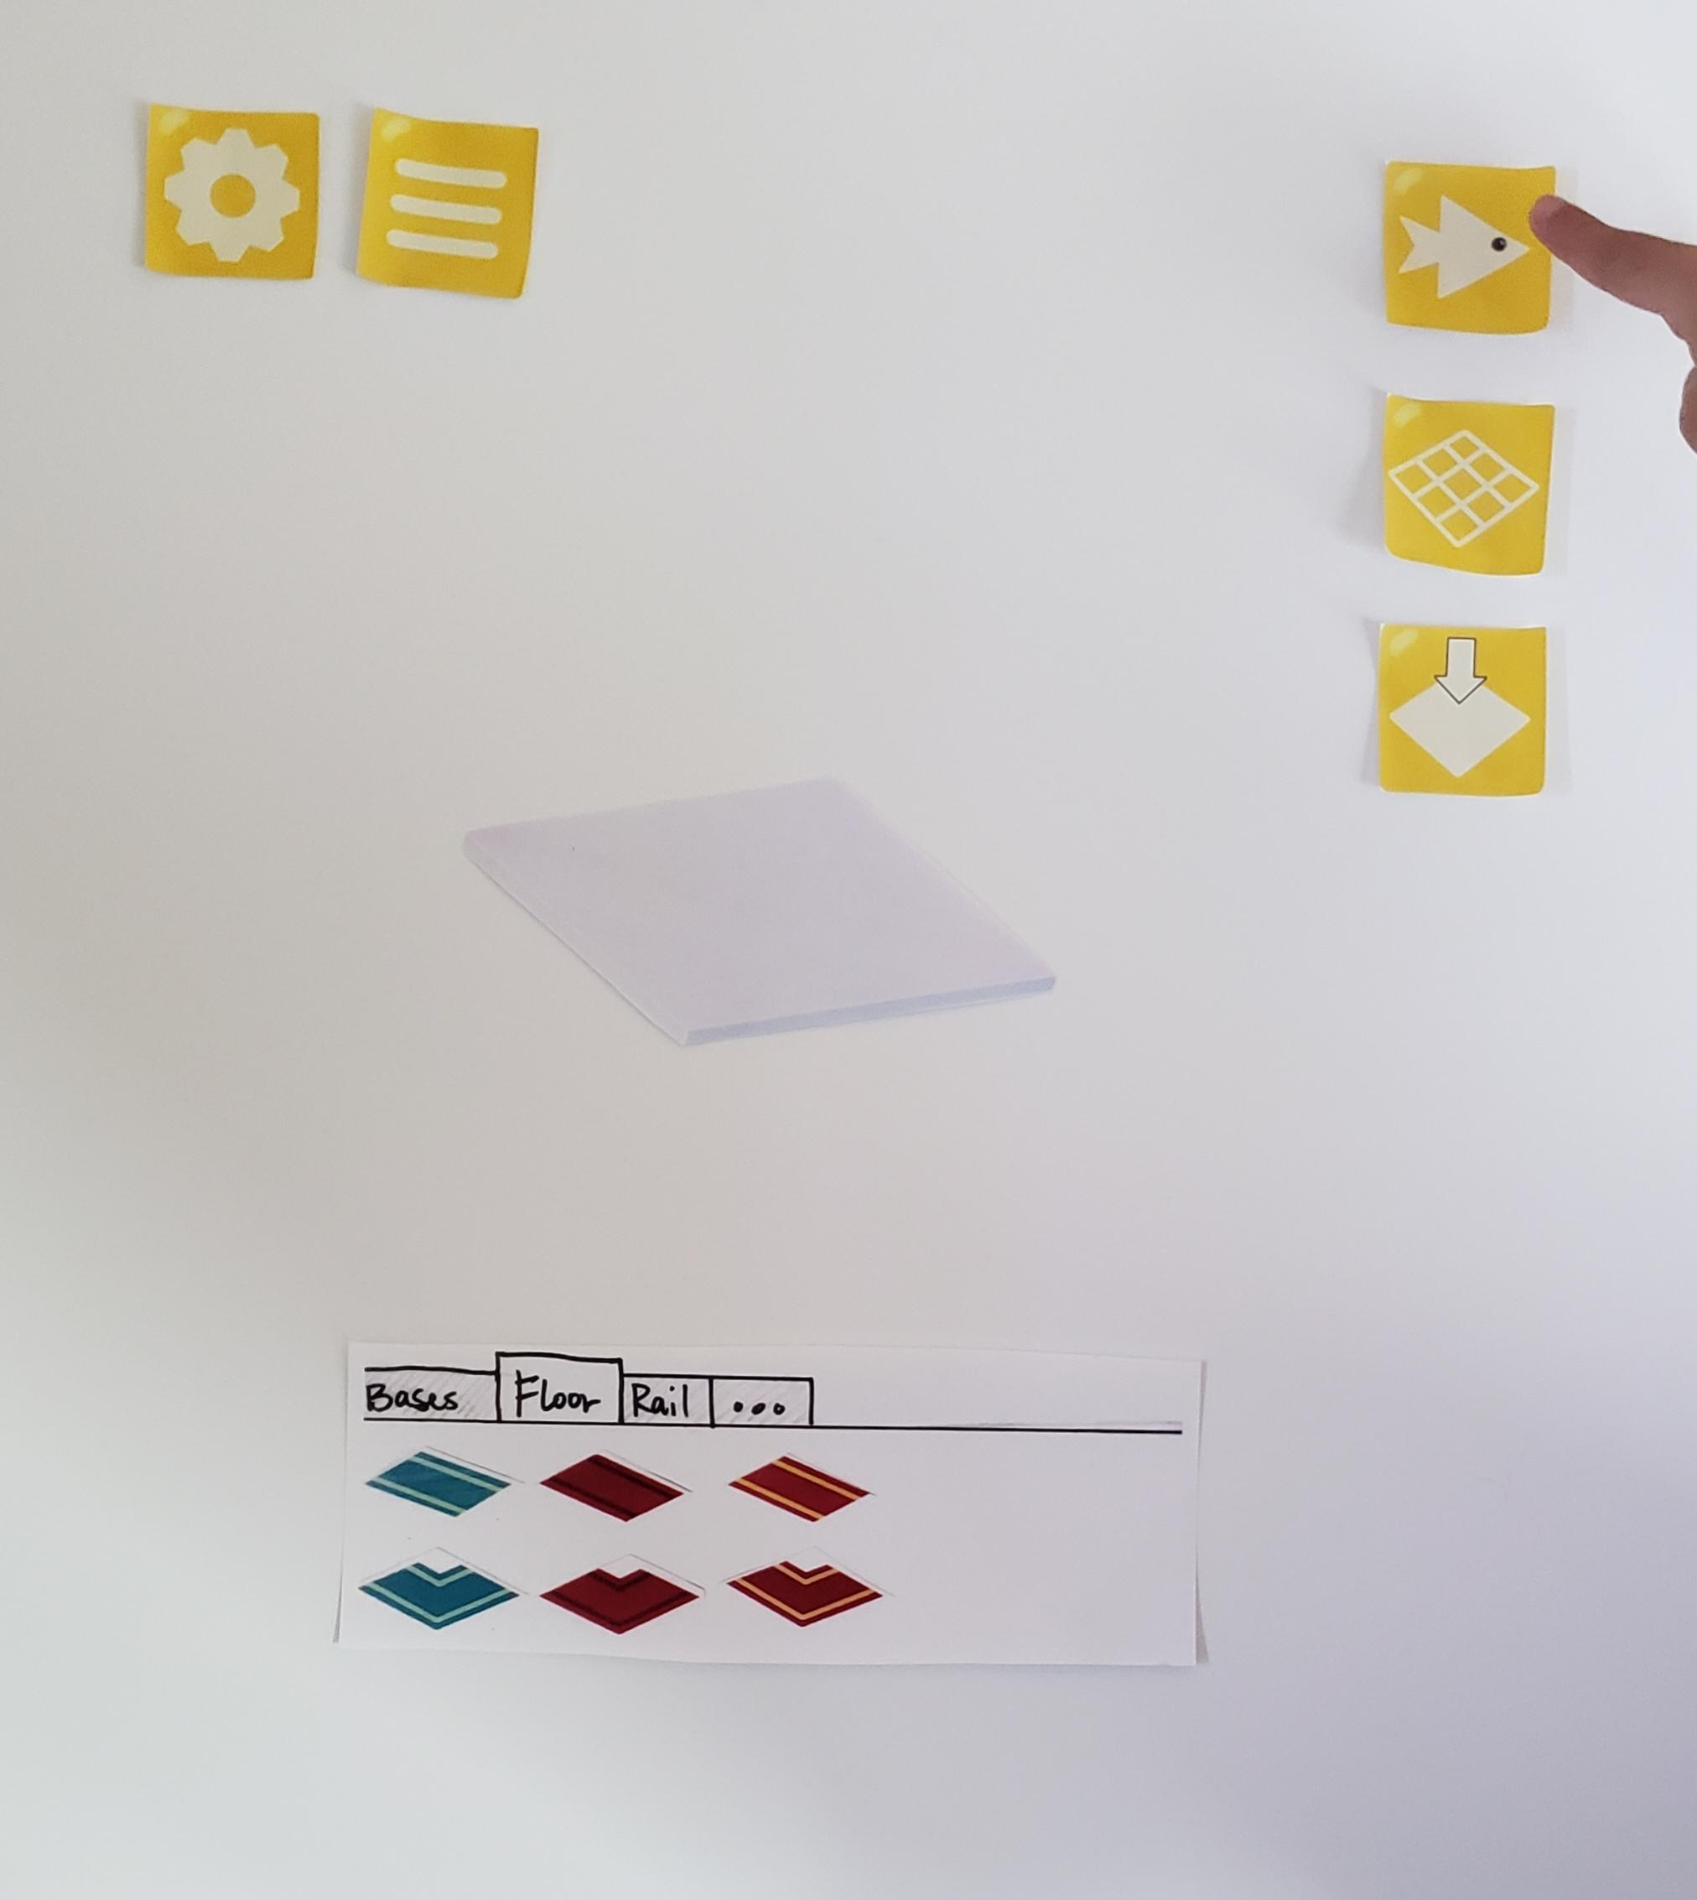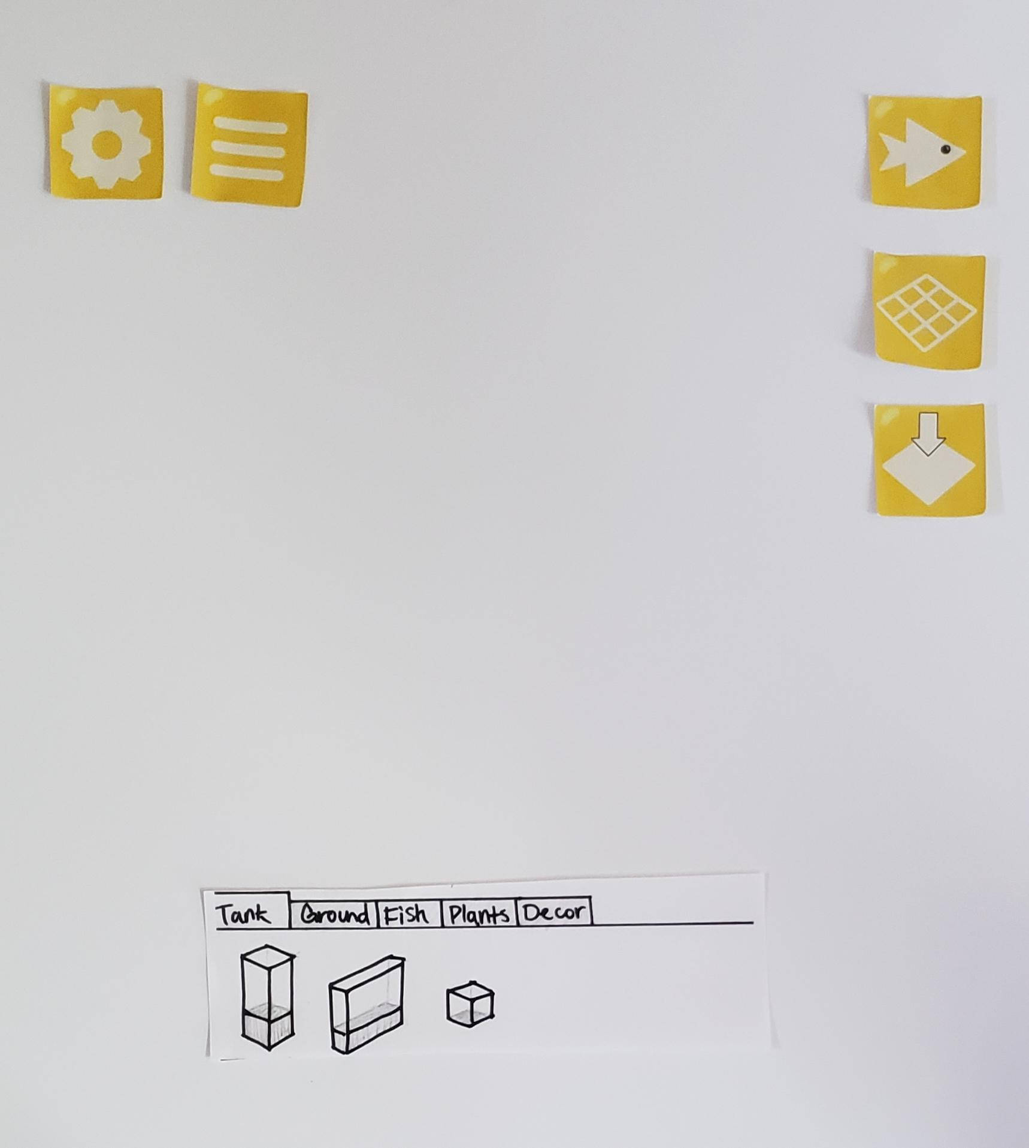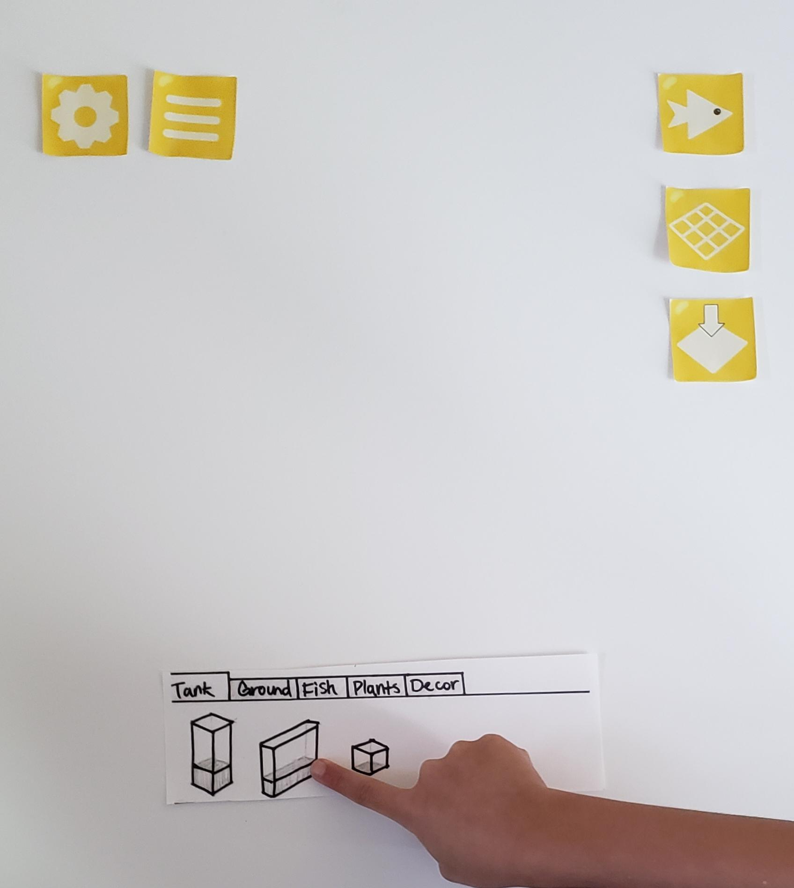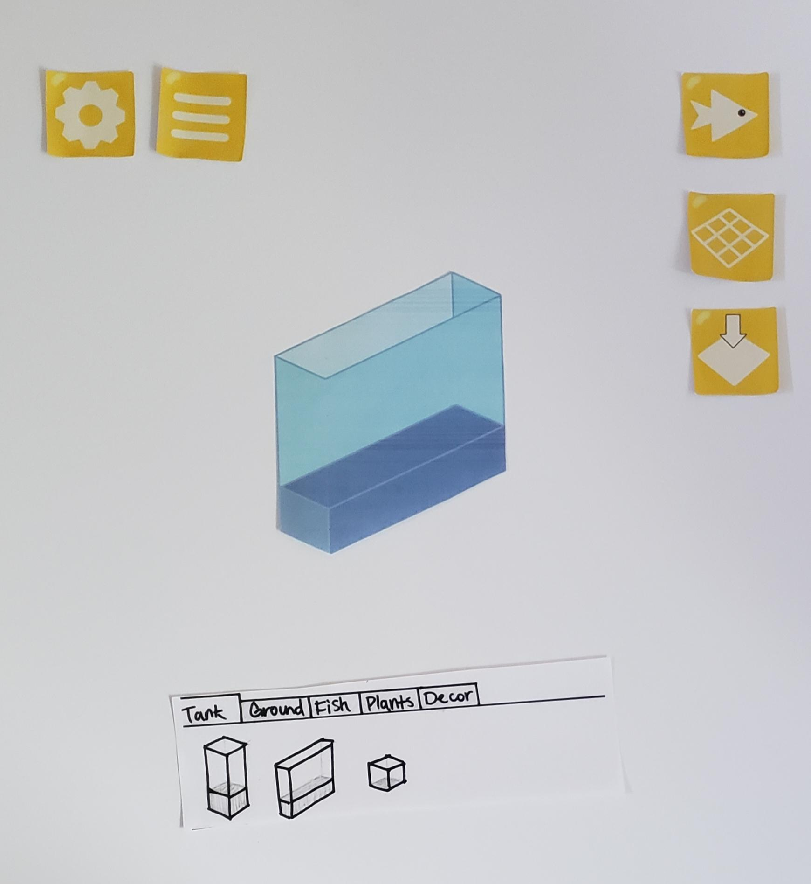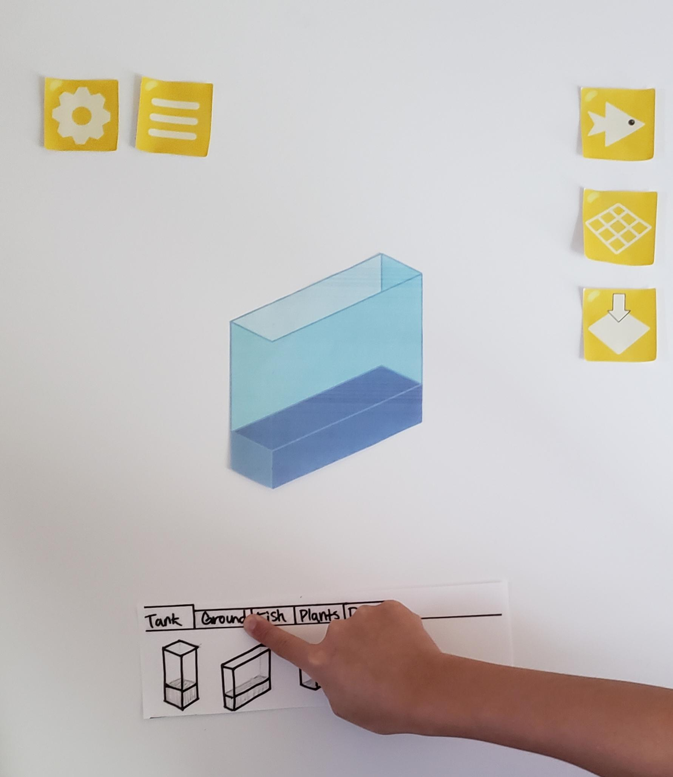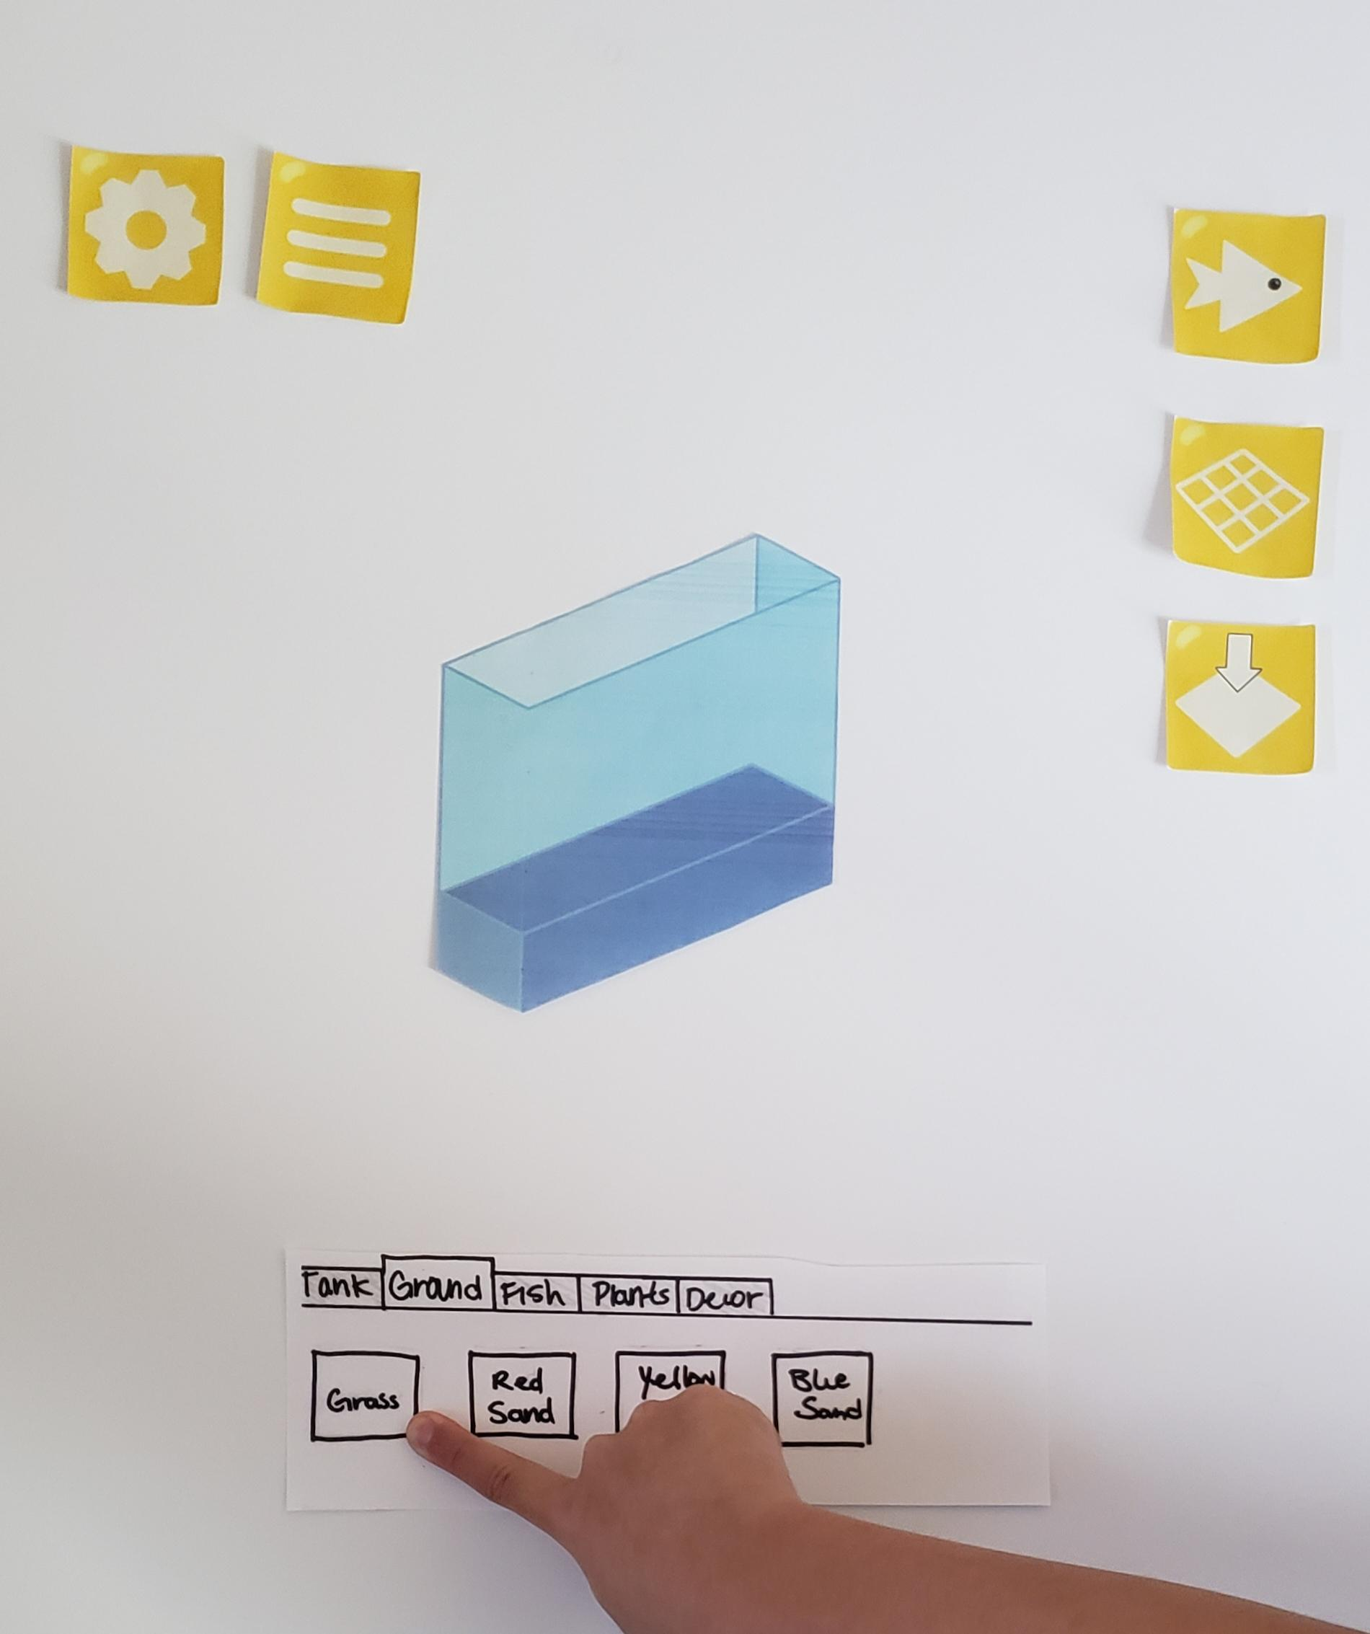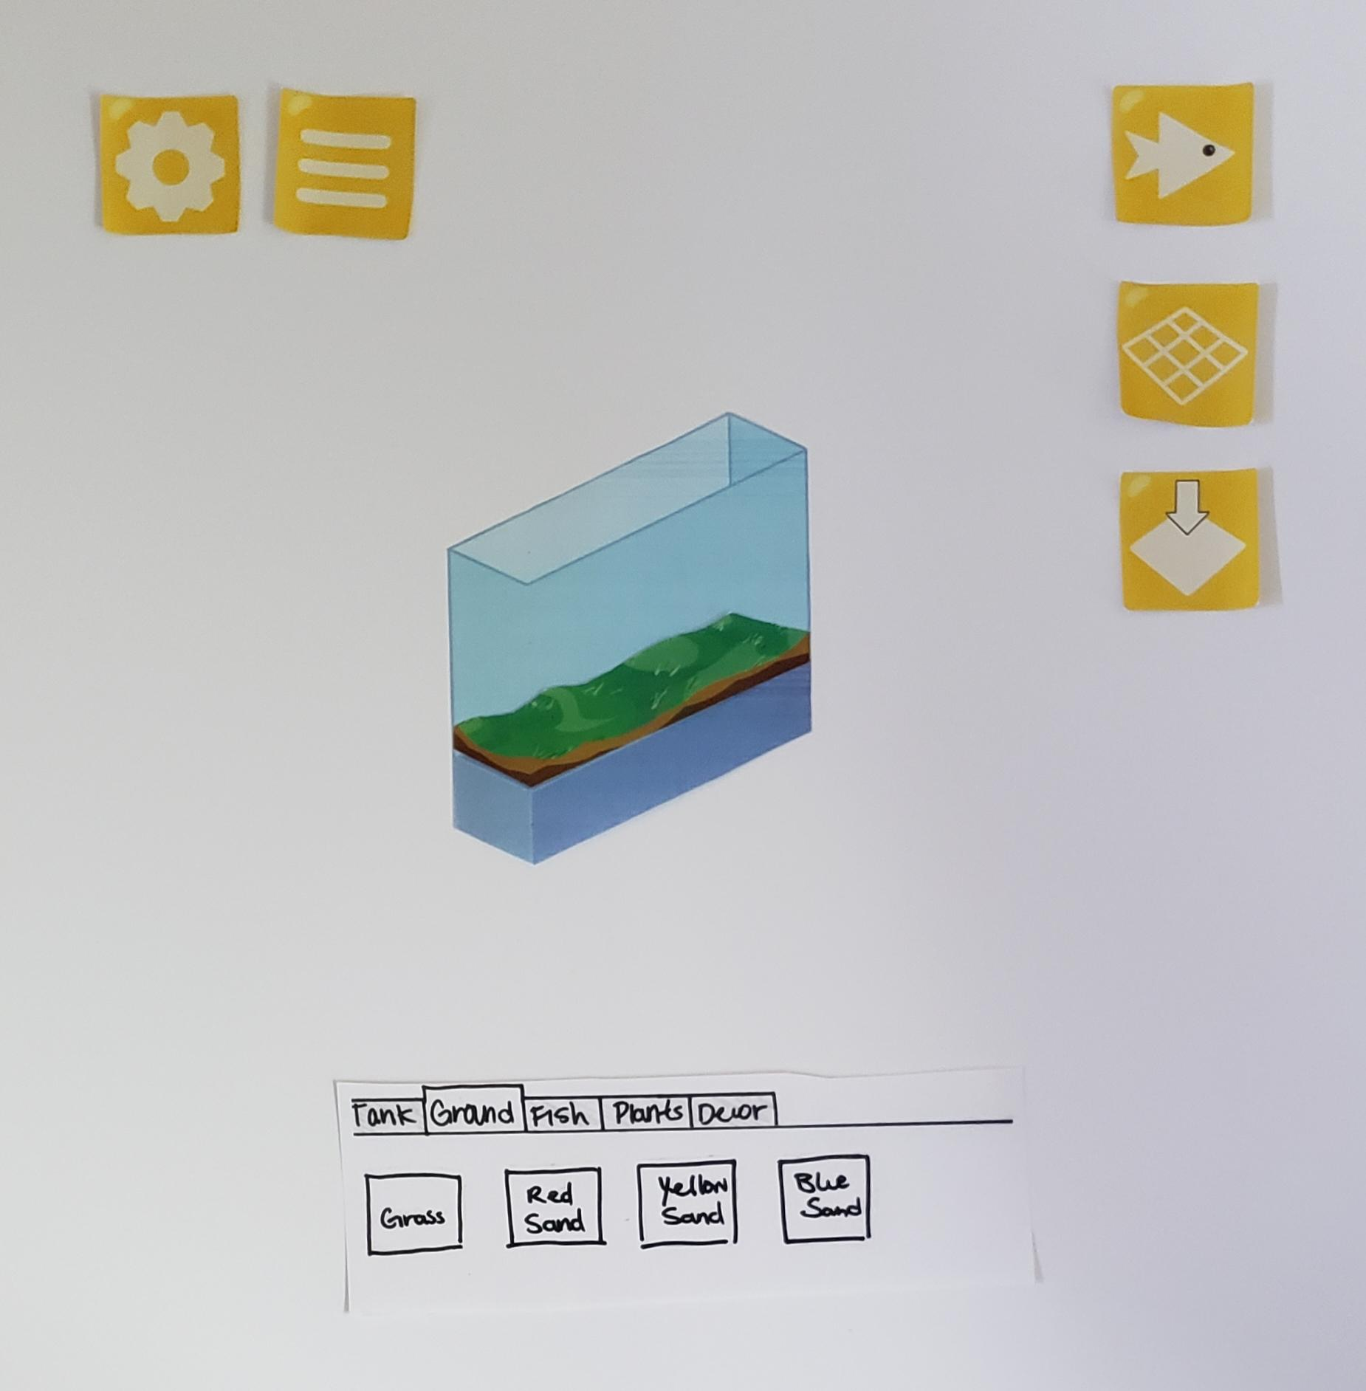

**Add Tank to Exhibit and Move into Place**

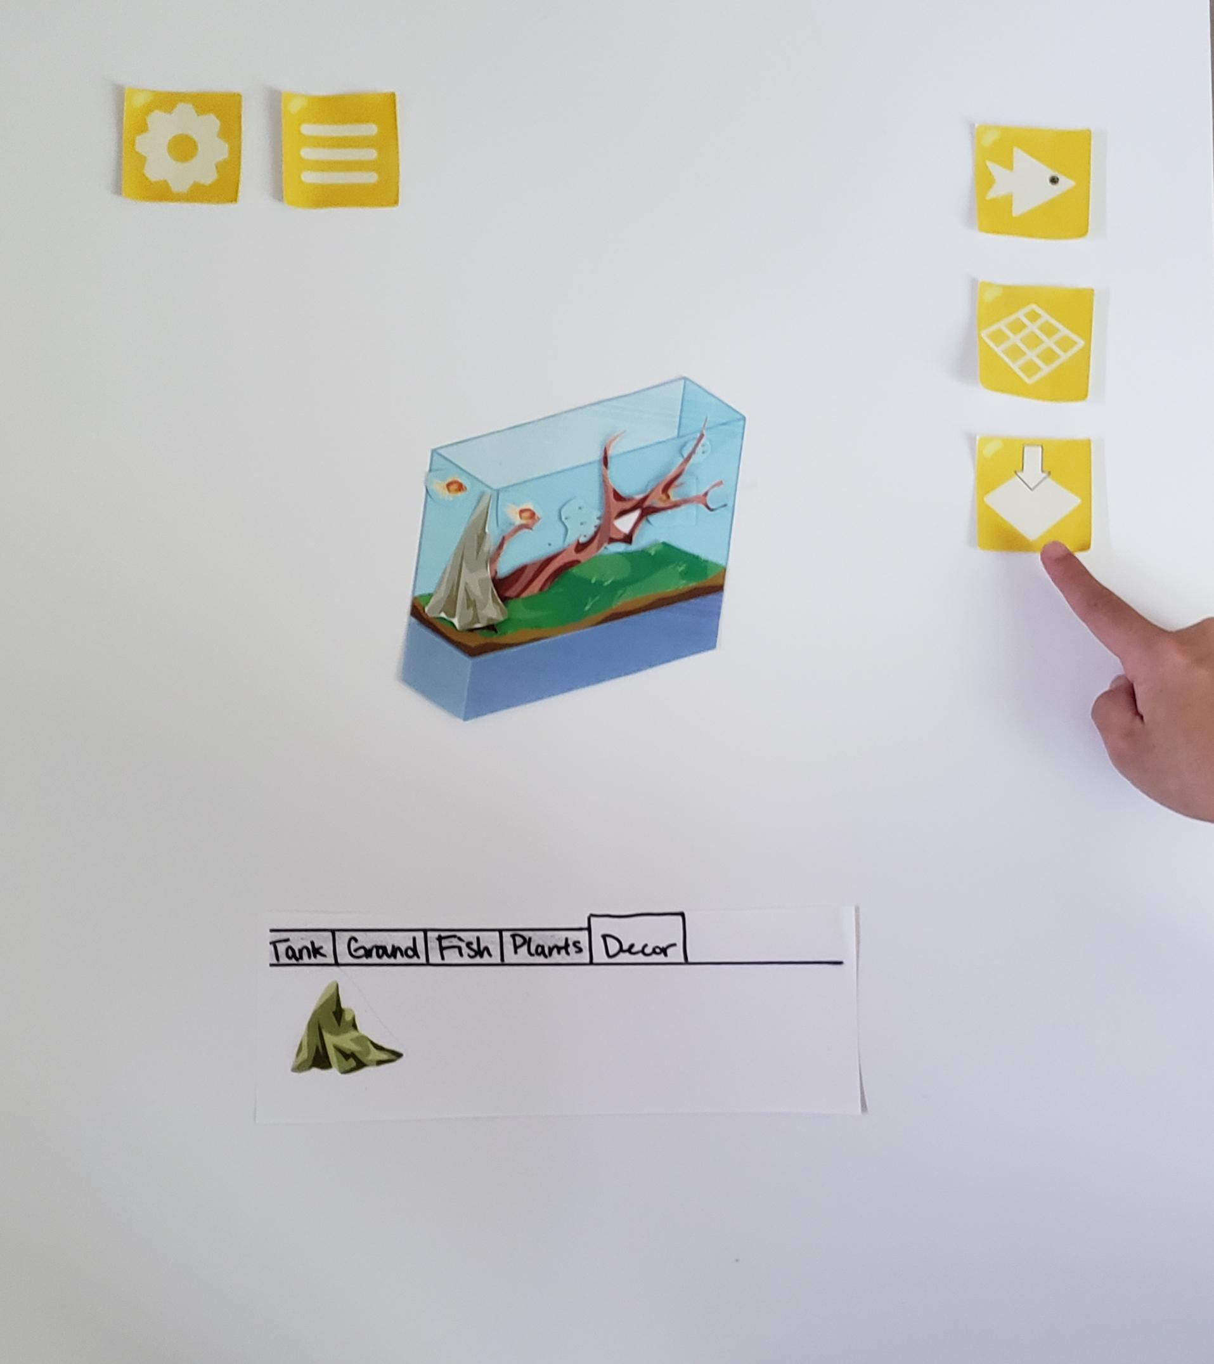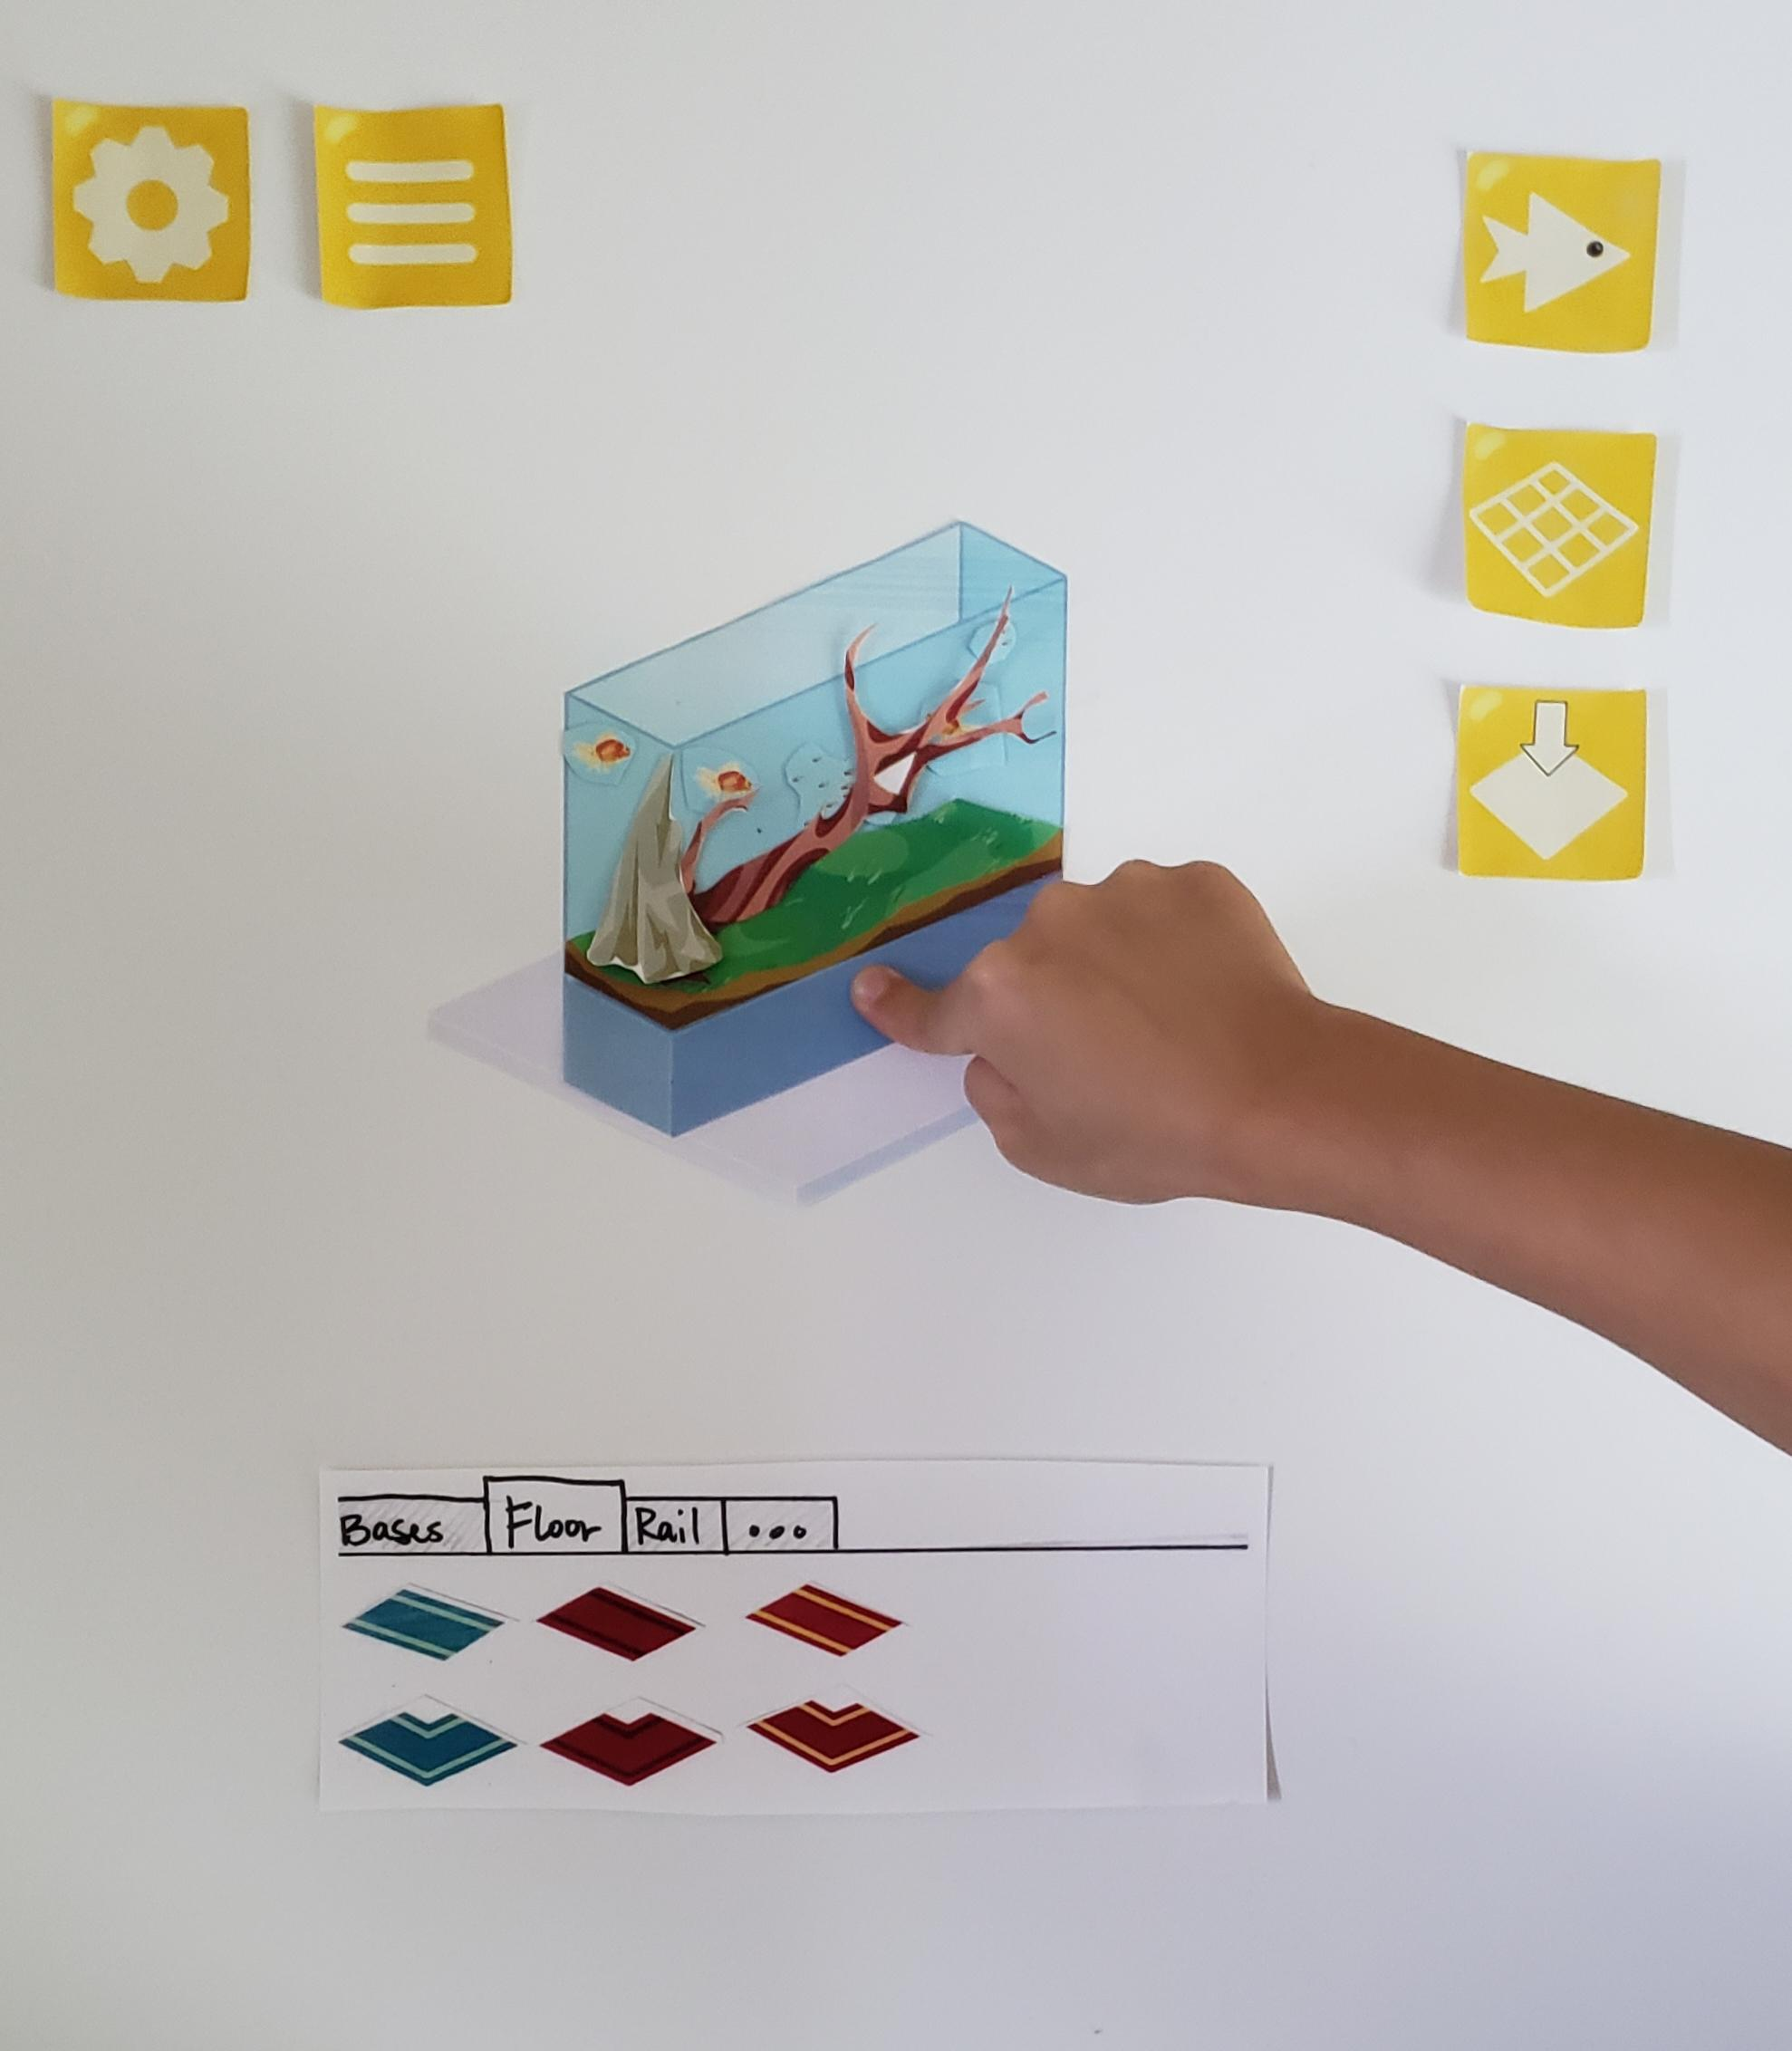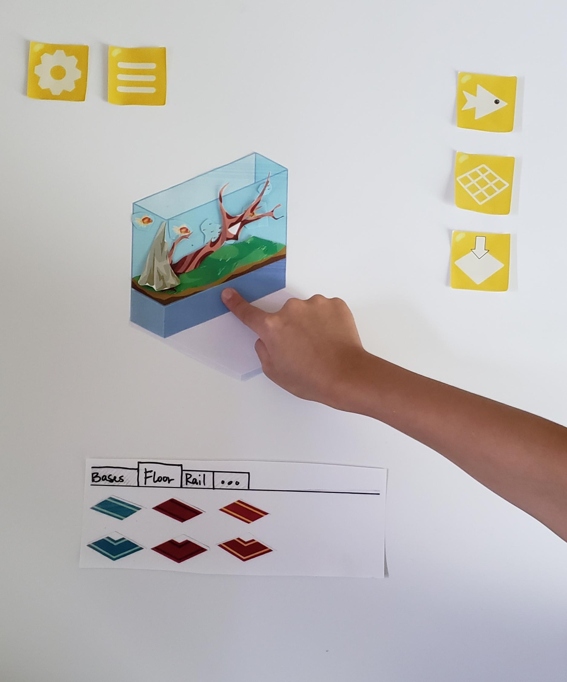

# Technology Plan

That plan is to release this on mobile devices (smartphones and tablets). The game will be developed using the Unity game engine, and written primarily in C#. Unity has excellent documentation and tutorial resources, it also gives us a lot of built-in tools to make sure that launching across multiple platforms goes as smoothly as possible.

We know that even before we really get into the guts of building the game, the most difficult part for the programming team will be the social networking aspect of the game. During a lot of the pre-production time, the programmers will be researching and prototyping out various networking options for the game. This will let them work towards a tangible solution when development enters production mode, and the designers will be able to use high-functionality and low-fidelity prototypes for players to test before they bring it to the programmers to make it work in Unity.

The artwork so far has been produced using Autodesk SketchBook. SketchBook provides a wide array of tools to create detailed and layered artwork that allows for professional results. This software is completely free and has a shallow learning curve, saving time and money in the development process. The artwork created using SketchBook can also be easily exported and implemented into Unity, bridging potential gaps between the art team and the development team.

# Mechanics Analysis

Players will be able to create their own aquarium aquascapes, and exhibits. The player is able to place items in the exhibit (a base, tank, and decorations), as well as fish in their aquarium based on a snap-grid placement system. Because the player will play the game on a mobile device, a snap-grid placement system will make placing objects easier on smaller screens while also limiting the amount of items that can be placed to prevent over cluttering the screen. The player will be able to see a semi-transparent outline of the item they are currently placing until they set it down in the tank.

Tank and exhibit decorations and fish earn a certain amount of in-game money idly. For example, a starting fish may earn a few coins every few seconds, while a late-game fish can earn more idly. If players like the designs of early items and still want to earn a substantial amount of coins from them idly, they can upgrade them using their coins.

As the player progresses through the game they are able to unlock more decorations, fish, and gallery space by leveling up. They level up by taking care of the fish (feeding and cleaning tanks daily) and by completing achievements for reaching milestones such as earning a certain amount of life-time in-game money. Once players level up, they will earn varying rewards each level: rewards may be in-game money, a temporary buff that increases the money earned idly or takes care of your tanks for you, or free new fish or decorations. In addition to this, the player will also be able to access/unlock special seasonal items that aren’t available any other time (only during special events), and have special visuals as well.

The player will also be able to complete daily tasks/goals to earn short-term rewards and experience and work towards long-term achievements that give bigger, exclusive rewards and experience.

Players can idly progress through the game. If the player has high-earning decorations or fish in their exhibit, that exhibit will earn more money idly. Additionally, there are temporary buffs that may be activated to increase the money earned idly for a certain time. Players may earn this as rewards for leveling up or completing certain achievements.

As the game is designed to be a casual, relaxing game, without any real fiero moments the game will focus on positive reinforcement. The player will be able to earn additional in-game currency and experience points by taking care of their fish daily, feeding them and cleaning the tank, both activities will be free, and as the goal is positive reinforcement, there will only be minor punishments for not taking care of the fish such as earning less money from that gallery idly the longer they go without care; this way, there is still some motivation to check in every so often so they can progress more efficiently on idle mode.

Additionally, the player will be able to choose if they want to exhibit their own tanks via social networking sites (Facebook, Twitter, Instagram). To encourage players to exhibit their own tanks, if a user shares their tank they can receive additional in-game currency by both views, and votes from other players. Players also have the option to share their exhibits of their choosing through the app itself. This way, they may earn likes on their tanks, contributing to the completion of achievements to earn experience points and further motivating players to design appealing exhibits.

In-App purchases will exist in the game as well. It will include many of the standard options for mobile games; in-game currency and buffs. It will also feature purchases that are more unique to Aquaroom; extra exhibit space, permanently double all earned in-game currency, earn a free daily lot of items everyday for two weeks.

# Schedule

Our estimated development schedule for this project is 6-8 months:

* 2-3 months of pre-production focusing on a vertical slice of the game
* 3-4 months of production time developing the rest of the game
* 1 month of post-production marketing, going to cons and events

This schedule gives us a month leeway during each phase where if things go smoothly we will either be able to launch early, or launch on-time with extra content. If things don’t go smoothly, this schedule still accounts for that and gives us an extra month during each of the pre-production, and production phases while still allowing us our month of post-production marketing.

# Budget

We estimate a budget of $150,000 to take this game from concept to completion. This will allow us to employ enough people, and still pay them a livable wage so that we may commit our full energies to this project.

We plan to employ a team of six people; two artists, two programmers, one designer, and one marketer. With our budget each person can earn approximately $2,000 a month, and we will still have some excess money each month that can be put towards covering unforeseen costs or put towards our post-production marketing campaign.

# Appendix

# Enhancing Player Experience

The goal of *Aquaroom* is to design the best looking exhibits. As such, players can share their exhibits through the app’s sharing system which allows other players to view and like an exhibit, or sharing via social media. This gives them the motivation to build better looking exhibits since they can compare their exhibits to those of other players.

Multiple mechanics of our game are meant to appeal to socializers, achievers, or explorers. The sharing mechanics appeal to socializer players who can experience some interaction with other players as a result of their creation. The game’s achievements are to appeal to achievers as there may be a variety of achievements as some may be earned quicker given certain strategies (e.g. achievement to earn *x* amount of coins within *y* minutes may be a late-game goal, but an achiever may see this early on and plan their upgrades and use of temporary buffs to achieve this goal quicker). Explorers can exercise their creativity in exploring the decorations the game has to offer, as well as explore other player’s exhibits.

With regards to chance, there will be varying weights of level-up rewards and some achievements will have mystery rewards that will also vary in weight alongside a fixed reward. Players will earn rewards every level up and sometimes the rewards will be better than others. The variability will not be so volatile to the point of disappointment (there will be some baseline), so rewards must still have some positive impact on the players progress with regards to in-game currency (proportional to the costs of the current level decorations).

An immersive theme that boosts endogenous value helps urge the player to invest more in the goal of the game. The aesthetics are meant to support a calming and relaxing emotions to fit the stress-free nature of this idle, design game. Since the decorations are all meant to look nice with each other, most design outcomes by the player still have some kind of cohesiveness. As such, they see value in what they’ve put together and are willing to explore more decoration choices, especially as more exhibit space opens up for them.

The UI is a vital part to the players ease of use when designing. To make navigating through the menus easier, they will take up more of the screen while the user browses the menus. Once they select an item, the view will shift in favor of the exhibit or tank so they can easily move the item around the exhibit or tank space. Additionally, the UI will have tabs to go between different items and can scroll within those menus akin to the UI standards in most mobile interfaces.

# Game Development Process Summary

The game development process began when each of us created our own game ideas and proposals. Each person introduced a unique game that needed varying amounts of time, money, and expertise to design and implement. We wanted to make sure the concept could be prototyped quickly using each group member’s skills, but still have high potential to survive in the gaming market. We decided to continue with *Aquaroom* for these reasons.

As we continued to think about what we wanted our game to look and play like, we refined the mechanics of what the player could view and how they would interact with the fish tanks and the environment. Since it is a mobile game with a simple interface and controls, we could begin creating a prototype to clearly show what the game would potentially look like. As the artwork became a clearly pivotal component, we made sure to develop enough to showcase the overall aesthetics during the playtesting.

# Playtesting

The playtest consisted of 4 observers, three players, and paper cutouts of all the initial assets that had been created. Initially, the observers briefly described the game and the objectives without giving too much detail into how players could achieve these goals. The idea was by limiting the information provided the observers could verify whether or not the interface and the game mechanics translated well with the players. In large part, the experiment was a success, with only some minor issues. The issues were stemming from the playtest itself and not the game. In the actual video game, objects (assets) would snap to particular points; on paper, this was not possible. This aspect of the playtest did not translate well. Overall the players understood what was supposed to happen and could move on from that point.

After letting the playtesters play with the game for a little, the observers then allowed the players to ask any questions about the game that was unclear to them. Feedback from the players was positive, and it appeared that they enjoyed playing the game. After the players felt like they understood the concept of the game, they were then asked a series of questions (Questions can be found in the Appendix section). These questions would help determine whether the playtest was a success. The players provided great feedback and remarked how they enjoyed the game, especially the artwork. The most significant concern that the players raised was the question about the game economy (e.g., how many coins an item costs, the cost of a fish, max coins a player could receive on daily rewards, etc.). The observers did not have an answer to these questions because they assumed it was too early in the process.

Overall the playtest appeared to be a success for the most part. In the future, we (as observers) will ensure that every playtest will, at the very least, have a rough idea for the game economy. This will help us gather better metrics and get a gauge at how receptive the "typical user" is to the cost of items within the game.

**Playtesting Questions/Process**

***Process:***

1. Have them:
   1. Navigate through the menus to design an exhibit
   2. Explain their thought process out loud
   3. Let them continue for as long as they want (reasonable within the session time)
2. Us:
   1. Observe the things they notice, overlook, or get stuck with
   2. Try not to intervene and let them figure it out for a bit
   3. Observe how long they spend decorating
   4. Record answers to questions

**Questions to ask play testers (Session #1 w/ group Free Will):**

1. What do you like best about the game?
   1. Building the aquascape in the tank. The beauty of the artwork
   2. Design and artstyle (color choice, minimal/detailed, cohesion, simple, works with mobile phones); variety of decorations
2. What do you think works well in the game?
   1. Everything is made to fit, nothing seems out of place (intuitive)
   2. UI; include labels/tutorial for the UI so people know what it is; overall easy to follow for the tabbed menus
3. What things (e.g. features, options, etc) do you:
   1. Wish were in the game?
      1. Zoom in/Zoom out
      2. More items
      3. Adjust the tanks and exhibit size easily (not through a menu but maybe extension arrows
4. Did you have any trouble navigating the interface?If so would you prefer there be a tutorial?
   1. Perhaps a tutorial
5. What was the most frustrating moment or aspect of what you just played?
   1. Floor placement (no grid)
   2. Flooring piece (paths don’t really make sense)
   3. Initial confusion in the buttons (right side)
6. What were you doing in the experience?
   1. Trying to make the tank better than other players
   2. Designing experience, build something from the ground up, freedom, staging my own perfect fish tank
7. How would you describe this game to your family and friends?
   1. Experience that allows you to showcase your creativity and to show off
   2. Fish tank management game with distinguished artstyle, fun/relaxing, visually stimulating
8. Would you play this game again (in digital form)?
   1. Yes
   2. Yes, probably as an idle app
9. How often do you think you would play this game?
   1. An estimate of time per day?
      1. 10-15min
      2. First time 30 mins, then a few mins a day
   2. How many days per week?
      1. 4-5 days
      2. daily -every other day
   3. What things (e.g., special events, new items) would keep you coming back after the first month?
      1. In-game special events, working with fish stores (QR code)
      2. Would pick it up more if they needed to take care of the space (something *needs* to change to make them come back)
      3. Events; special items, daily rewards system
10. How emotionally invested were you in the game?
    1. Not really that much
    2. If there were more options, would probably sit on it more (interested in visuals/aesthetics to admire)
    3. Designing is the fun part so initially quite invested
11. Would you recommend the game to others?
    1. Yes
    2. Yes, fun, artstyle, designing your own tank

**Aesthetic Questions:**

1. What were some of the things you liked about how the game looked?
   1. Symmetry of the artwork

1. Were there any aesthetics that you wish you could:
   1. Add?
      1. More decorations (e.g., house)
   2. Remove?
      1. N/A
   3. Change?
      1. N/A
      2. Goldfish too shiny
2. What about the visuals caught your eye the most?
   1. The tank itself, colors

**Story Questions*:**

1. Would you prefer if the game had a little backstory to it?
   1. If so how would you prefer the story being told you?
      1. Passive conversations (user is not involved) between characters (e.g., Pokemon Go or Wizards Unite)?
      2. Facts about each item? Unusual fun facts?
         1. No story, fun facts about fish would be cool
         2. No, just focus on design, adding story, doesn’t really add to design, exp in design itself

**Mechanics Questions:**

1. Did you find placing items inside the tank or in the gallery difficult?
   1. Without the grid yes, with it no
   2. The floor
2. Would you prefer items to snap to a location or would you want more free reign?
   1. Snap
   2. Snapping
3. Did you find anything in the game to be challenging?
   1. N/A

1. Would you prefer if there were consequences to certain actions (e.g., not feeding the fish or cleaning out the tank)?
   1. Extra fee (in game currency) for not fulfilling responsibilities (e.g., not cleaning tank or feeding fish)

**Technology Questions:**

1. Would you play this game on a different platform other than your phone?
   1. Nope, maybe tablet
   2. ipad/tablet; switch (touch screen)
2. Would you allow this game these permissions on your phone:
   1. In-app purchases - Allows user to make in game purchases
      1. Yes
      2. Yes
   2. Location - Allows user to check in a special spots (fish store locations)
      1. No
      2. No
   3. Camera - Allows user to take pictures of special codes at fish store locations
      1. Yes
      2. Yes
   4. Storage - Allows app to read/save files to your storage device
      1. Yes
      2. If not on cloud then yes
   5. Identity - Allows app to sign you in with other accounts (e.g., Facebook, Google)
      1. Yes
      2. Yes